Digital Payment Infrastructure and the Structural Transformation of Small-Cap Volatility: Evidence from India’s UPI Expansion, Retail Herding, and Regulatory Interventions.

A Project Report submitted to
Indian Institute of Information Technology, Allahabad
In the partial fulfilment for the
Degree of Master of Business Administration

Under the Supervision of
Prof. Shailendra Kumar

By
Aditi Pandey
April-2026

INDIAN INSTITUTE OF INFORMATION TECHNOLOGY, ALLAHABAD
Deoghat, Jhalwa, Allahabad, U.P., India 211012


भारतीय सूचना प्रौद्योगिकी संस्थान,इलाहाबाद Indian Institute of Information Technology, Allahabad An Institute of National Importance by Act of Parliament Deoghat, Jhalwa, Prayagraj-211015 (U.P) India
Ph No: 0532-2922025, Fax:0532-2922125, Web:www.iiita.ac.in, E.mail: contact@iiita.ac.in
STUDENT'S DECLARATION

I hereby declare that the Fourth Semester Master Project prepared by Aditi Pandey titled Digital Payment Infrastructure and the Structural Transformation of Small-Cap Volatility: Evidence from India’s UPI Expansion, Retail Herding, and Regulatory Interventions is an original piece of work done by me under the supervision of Prof. Shailendra Kumar.
This is a purely fresh work which is done by me and there is no competitive work available in academic domain/providers of items or services of proprietary domain.

I have taken certain information relevant to our study from various journals and books which we have listed in the References section.

I have used certain documents for our reference.

I declare that the submitted work has not been undertaken elsewhere and is free from plagiarism.

Place: Prayagraj Aditi Pandey
Date: 27/04/2026

CERTIFICATE

Recommended in partial fulfillment of the requirement for the award of Degree of Master of Business Administration (MBA).

[Internal Guide]


भारतीय सूचना प्रौद्योगिकी संस्थान,इलाहाबाद Indian Institute of Information Technology, Allahabad An Institute of National Importance by Act of Parliament Deoghat, Jhalwa, Prayagraj-211015 (U.P) India
Ph No: 0532-2922025, Fax:0532-2922125, Web:www.iiita.ac.in, E.mail: contact@iiita.ac.in

Checklist for MBA project reports of Six months Duration
1. Name of Student(s) with Roll No.
Aditi Pandey (IMB2024016)

2. Title of the Project:

Digital Payment Infrastructure and the Structural Transformation of Small-Cap Volatility: Evidence from India’s UPI Expansion, Retail Herding, and Regulatory Interventions

3. List of Computer resources used in addition to general network connected PC hardware, Please mention below if any Software including operating systems(s), compilers(s) any 4GL(s), S/W tools, libraries were used duly mentioning their type (open source / Free and open source / shareware / proprietary or any other) with version number of the resource.

Windows 11
MS Office 365
Mendeley
Python
4. Category of the Project & your contribution claimed
- Research Project
- Study the Micro-finance in Allahabad & surrounding region and analyzing the impact of it in improving access of financial service to the poor.

5. Claims of the work done in light of competitive work & material already available in academic domain / products' / providers of items or services of proprietary domain.

PLAG REPORT

ACKNOWLEDGMENT
I am deeply grateful to my mentor, Prof. Shailendra Kumar (Internal Guide) for his unwavering support and guidance throughout my master's program. Their expertise and patience have been invaluable to me and have played a crucial role in the success of this project.
I am grateful to Indian Institute of Information Technology, Allahabad for providing me with the opportunity to conduct my research and for all of the resources and support they provided.
I am grateful to Ms. Ishita Srivastava , Mr. Shivansh Mishra and Mr. Jayant Singh for their constant support , guidance and motivation throughout this journey .
I am deeply thankful to God , my friends and family for their love and support during this process. Without their encouragement and motivation, I would not have been able to complete this journey.
I am grateful to everyone who has supported me throughout this process. Without their help and guidance, this project would not have been possible.

Sincerely,
Aditi Pandey
(IMB2024016)

Abstract
India’s Unified Payments Interface (UPI) expanded from early-stage adoption in 2018 to mass scale by 2024, potentially altering household-to-market money flows, trading frictions, and the microstructure of retail-dominated segments. This study tests whether UPI-led digitalization is associated with changes in small-cap volatility using monthly realized volatility for the Nifty Small cap 100 and Nifty 50 (January 2018–January 2025 for UPI-linked analyses; 85 monthly observations). We document a large decline in small-cap realized volatility over the sample and a persistent but narrowing excess-volatility wedge relative to large caps. Newey–West HAC regressions show a strong negative association between ln(UPI transaction volume) and small-cap realized volatility ( = 3.19, t = 14.39), robust to controlling for large cap volatility, a COVID regime indicator, and a linear trend. Chow tests indicate multiple structural breaks aligned with UPI scaling milestones and market-structure reforms (e.g., Oct 2019, Mar 2020, Jan 2021, Sep 2021, Jan 2022, Jan 2023). Granger causality tests support directionality from UPI growth to subsequent volatility (lags 1–4), while the reverse direction is weaker and less stable. The findings are consistent with a “digitalization–liquidity channel” in which reduced payment/funding frictions and broader participation strengthen market depth and dampen volatility, with marginal effects attenuating after the retail surge around 2021. Practical implications follow for payment-platform strategy, brokerage/onboarding design, and regulator monitoring of retail flow externalities.

Table of contents
CONTENTS:
I. Abstract 6
II. List of figures 8
III. List of tables 9
IV. Abbreviations & symbols used 10
1. INTRODUCTION 11
2.LITERATURE REVIEW 12
a. RESEARCH QUESTIONS AND HYPOTHESIS DEVELOPMENT 12
3.METHODOLOGY: 13
a. Data and Variable Construction: 13
b. Descriptive Statistics: 14
c. Steps: 15
4. DATA ANALYSIS AND RESULTS: 16
a. Sub-Period Volatility Comparisons: 16
b. UPI–Volatility Regressions (HAC): 16
c. Correlation Structure: 17
d. Structural Break Tests: 17
e. Attenuation Around the Retail Surge Breakpoint: 18
f. Temporal Directionality: Granger Causality: 18
g. Robustness Checks: 18
h. Visual Evidence: 19
DISCUSSION: 22
CONCLUSION: 24
LIMITATIONS AND FUTURE RESEARCH: 24
REFERENCES: 25
APPENDIX: 27
CERTIFICATE 28

List of figures
Figure No. | Title
Figure 1 | UPI Transaction Growth and Small cap 100 Realized Volatility (2018–2025)
Figure 2 | Rolling 60-Day Volatility Ratio and Rolling Return Correlation (Exploratory)
Figure 3 | Monthly Realized Volatility: Nifty 50 vs Small cap 100 (2018–2025)
Figure 4 | UPI Digitalization and Small-Cap Volatility: Scatter Evidence
Figure 5 | Sub-Period Volatility Comparison (Mean Realized Volatility)

List of tables

Table No. | Title
Table 1 | Descriptive Statistics (Monthly, 2018–2025; N = 85)
Table 2 | Sub-Period Mean Realized Volatility and Volatility Ratio
Table 3 | UPI Scale and Smallcap 100 Realized Volatility: HAC Regressions
Table 4 | Model Fit Statistics
Table 5 | Correlation Matrix
Table 6 | Chow Structural Break Tests for the UPI–Volatility Relation
Table 7 | Interaction Model Around January 2021 Break
Table 8 | Granger Causality Tests (SSR F-tests)
Table 9 | Lagged ln(UPI) Regressions (Controls: N50 Volatility and COVID)
Table 10 | Alternative UPI Proxy (Value) Regression (Controls: N50 Volatility and COVID)

Abbreviations & symbols used

Term | Meaning
UPI | Unified Payments Interface
NPCI | National Payments Corporation of India
RBI | Reserve Bank Of India
SEBI | Securities and Exchange Board of India
SC100 | Nifty Small cap 100
N50 | Nifty 50
HAC | Heteroskedasticity and Autocorrelation Consistent
OLS | Ordinary Least Squares
SSR | Sum of Squared Residuals
RV | Realized Volatility
VR | Volatility Ratio
β | Regression coefficient
ln | Natural logarithm
R² | Coefficient of determination
*** | Significant at 1% level
** | Significant at 5% level
* | Significant at 10% level

INTRODUCTION
India has experienced one of the fastest payment-system transformations globally. The Unified Payments Interface (UPI) enabled interoperable, real-time retail payments and scaled rapidly through product innovation (e.g., QR acceptance, UPI AutoPay) and policy support (National Payments Corporation of India [NPCI], various years; Reserve Bank of India [RBI], various years). While digital payments are typically studied through financial inclusion, consumer welfare, and transaction-cost lenses (Suri & Jack, 2016; World Bank, 2022), the same infrastructure can also reshape household liquidity management and “on-ramp” friction into financial markets. In India, UPI is tightly integrated with brokerage funding, mutual fund SIP top-ups, and mobile-first investing, which makes it a plausible upstream driver of retail flow characteristics.
Small-cap equities are a natural laboratory for these dynamics. Compared with large caps, small caps are more sensitive to liquidity shocks, investor composition, and constraints on market making (Amihud, 2002; Kyle, 1985; O’Hara, 1995). Retail trading can amplify volatility through attention-driven demand and herding (Barber & Odean, 2008; Bikhchandani, Hirshleifer, & Welch, 1992), but it can also reduce volatility by deepening order flow and increasing risk-sharing when the participation base widens and funding frictions fall (Chordia, Roll, & Subrahmanyam, 2001; Madhavan, 2000). Whether digital payment diffusion stabilizes or destabilizes small-cap volatility is therefore an open empirical question.
This paper asks: Did UPI-led digitalization coincide with a structural change in small-cap volatility in India? Using monthly realized volatility for the Nifty Small cap 100 and Nifty 50, merged with monthly UPI transaction volume and value, we estimate the association between UPI scale and volatility, test for breakpoints aligned with major adoption milestones and market reforms, and assess temporal directionality using Granger causality. The analysis is designed to be implementable with public, auditable series and straightforward econometric procedures suitable for a management/finance audience.
Contribution. First, we operationalize UPI scale as a macro-financial digitalization variable and connect it to equity volatility through a microstructure-informed mechanism. Second, we show that the UPI–volatility relation is not a single, stable slope: multiple structural breaks appear around key periods of retail participation and regulatory change. Third, we provide a defensible directionality check (Granger causality and lagged specifications) while clearly stating identification limits.

2.LITERATURE REVIEW
Digital payments and financial inclusion. A large literature shows that digital payment rails can expand access, reduce transaction costs, and improve risk sharing (Jack & Suri, 2014; Suri & Jack, 2016; World Bank, 2022). Policy and industry reports describe UPI as a cornerstone of India’s retail payment stack (NPCI, various years; RBI, various years). However, the equity-market implications of payment diffusion are less studied.
Market microstructure, liquidity, and volatility. Volatility is shaped by trading frictions, order flow toxicity, information asymmetry, and inventory risk borne by intermediaries (Kyle, 1985; Madhavan, 2000; O’Hara, 1995). Empirically, measures of illiquidity and transaction costs are linked to higher return volatility and lower price efficiency (Amihud, 2002; Hasbrouck, 2007). Expanding participation can either stabilize (via deeper liquidity and risk-sharing) or destabilize (via noise trading and correlated behaviour) markets, particularly in small caps where liquidity is thinner.
Retail investor behaviour and herding. Behavioural finance emphasizes that retail investors may exhibit attention-based trading, disposition effects, and herding, which can increase co movement and volatility (Barber & Odean, 2008; Bikhchandani et al., 1992; Chang, Cheng, & Khorana, 2000). Yet, the net market-level effect depends on whether participation is speculative and synchronized or diversified and systematic. In India, regulatory and infrastructure changes (margin rules, settlement cycle changes) may alter both retail behaviour and microstructure.
Research gap. Prior studies typically examine (a) determinants of digital payment adoption, (b) retail herding in equities, or (c) volatility in response to regulatory reforms, but rarely connect a national payments infrastructure shock to equity-volatility dynamics using a transparent event-and-time-series design. This paper fills that gap by using UPI’s time-series expansion as a macro-digitalization variable and evaluating its association with small-cap volatility using realized volatility measures, structural breaks, and Granger causality.

RESEARCH QUESTIONS AND HYPOTHESIS DEVELOPMENT
The study is organized around five research questions (RQs) and associated hypotheses (Hs).
RQ1. Is UPI scale associated with small-cap realized volatility?
H1. Higher UPI transaction volume is associated with lower realized volatility of the Nifty Smallcap 100.
RQ2. Does UPI scale relate to the small-cap excess-volatility wedge relative to large caps?
H2. Higher UPI transaction volume is associated with a lower volatility ratio (Smallcap 100 volatility / Nifty 50 volatility).
RQ3. Is the UPI–volatility relation stable over time?
H3. The UPI–volatility relation exhibits statistically significant structural breaks aligned with major adoption and market-structure events.
RQ4. Is there evidence of temporal directionality from UPI growth to volatility changes?
H4. UPI growth Granger-causes subsequent changes in small-cap volatility and the volatility ratio more strongly than the reverse direction.
RQ5. Does the marginal effect of UPI scale weaken as adoption matures?
H5. After the retail surge period (around early 2021), the marginal association between UPI scale and volatility becomes less negative (attenuation).

3.METHODOLOGY:

Data and Variable Construction:
Sample and sources: The core dataset merges monthly UPI statistics with monthly realized volatility for two Indian equity indices. UPI monthly transaction volume (in millions) and transaction value ( crores) span January 2018 to January 2025 (85 usable months due to missing UPI values for February–December 2025). Equity index series cover January 2018 to December 2025; however, UPI-linked regressions use only the overlapping months with UPI data.
Equity indices and returns: We use daily closing values for the Nifty Smallcap 100 and Nifty
50 indices. Daily log returns are computed as _{rd} = ln(_{Pd}/P_{d−1}).
Monthly realized volatility. Monthly realized volatility is computed as the square root of the sum of squared daily log returns within each month, annualized: _{RVm} 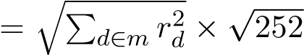. The series is reported in percent.
UPI digitalization measures: The primary measure is ln(UPI volume), the natural log of monthly UPI transaction volume in millions. Robustness checks use ln(UPI value) based on monthly transaction value in crores.
Control variables: Market-wide volatility is proxied by Nifty 50 realized volatility. A COVID regime dummy equals 1 from March 2020 through June 2021 to capture pandemic-era turbulence. Some models include a linear time trend.
Derived outcome measures. Small-cap excess volatility is measured using the volatility ratio:
V Rt = RVtSC100/RVtN50.

Descriptive Statistics:

Period | Nifty 50 Vol Mean | SC100 Vol Mean | Vol Ratio Mean | t-test (SC vs N50
Pre-COVID (2018-01 to 2020-02) | 14.60 | 27.73 | 1.90 | 11.15***
COVID (2020-03 to 2021-06) | 25.90 | 41.78 | 1.62 | 7.49***
Post-COVID (2021-07 to 2022-12) | 14.11 | 23.76 | 1.68 | 9.15***
Mature UPI (2023-01 to 2025-01) | 12.63 | 20.10 | 1.59 | 12.38***
Table 1 reports summary statistics for the key variables used in UPI-linked analyses. Small-cap realized volatility averages 28.17% (annualized), higher than Nifty 50 volatility (16.47%), consistent with thin liquidity and higher idiosyncratic risk in small caps. UPI volume averages 4,773 million transactions per month with substantial variation, reflecting the rapid scaling process. Table 2 compares mean volatility across four sub-periods: Pre-COVID, COVID, Post-COVID, and Mature UPI. The mature UPI regime ends in January 2025 due to missing UPI values for later. 2025 months. The small-cap volatility wedge narrows over time, with statistically significant differences between small-cap and large-cap volatility in each sub-period
Table 1
Descriptive Statistics (Monthly, 2018–2025; N = 85)

Variable | Mean | Std. Dev. | Min | Max
SC100 Realized Vol (%) | 28.17 | 10.31 | 13.82 | 56.74
Nifty 50 Vol (%) | 16.47 | 6.36 | 8.95 | 36.31
Volatility Ratio | 1.75 | 0.43 | 1.17 | 3.01
UPI Volume (million) | 4773.16 | 3568.72 | 620.00 | 13120.00
ln(UPI Volume) | 8.19 | 0.76 | 6.43 | 9.48
Table 2
Sub-Period Mean Realized Volatility and Volatility Ratio

Steps:
We implement three complementary strategies: (1) descriptive comparisons by sub-period, (2) time-series regressions with HAC inference, and (3) breakpoint and directionality tests.
Baseline association models. We estimate monthly regressions of small-cap realized volatility on UPI scale using progressively richer specifications:
Model 1: SCV ol_{t} = +ln(UPI_{t})+_{t}
Model 2: SCV ol_{t} = +ln(UPI_{t}) + N50V ol_{t}+_{t}
Model 3: SCV ol_{t} = +ln(UPI_{t}) + N50V ol_{t} + COV ID_{t}+_{t}
Model 4: SCV ol_{t} = +ln(UPI_{t}) + N50V ol_{t} + COV ID_{t} + Trend_{t}+_{t}
Estimation uses Newey–West heteroskedasticity-and-autocorrelation-consistent (HAC) standard errors with 3 lags to address serial dependence common in monthly macro-financial series (Newey & West, 1987).
Sub-period comparisons: We compare mean realized volatility by regime (Pre-COVID, COVID, Post-COVID, Mature UPI) using paired t-tests between the Smallcap 100 and Nifty 50 volatility series. The Mature UPI regime ends in January 2025 due to missing UPI values for later 2025 months.
Structural breaks: To test whether the UPI–volatility slope changes at specific dates, we apply Chow tests at candidate break months aligned with adoption milestones and market-structure reforms (Chow, 1960). These tests examine whether pooled regression residual variance is significantly reduced by estimating separate pre/post regressions.
Attenuation test: We estimate an interaction model around the retail surge breakpoint (January 2021):
SCV ol_{t} = +ln(UPI_{t}) + D_{p}ost_{t} + (D_{p}ost_{t}Öln(UPI_{t}))+_{t},
where _{D}__{post}__{t} equals 1 from January 2021 onward. A positive indicates attenuation (a less negative slope) in the post-break period.
Directionality: Granger causality tests evaluate whether past UPI values improve prediction of future volatility beyond past volatility alone (Granger, 1969). We report SSR-based F-tests for lags 1–4 and test both directions (UPI → volatility and volatility → UPI). We complement this with lagged-ln(UPI) regressions that use the same control set as Model 3.

DATA ANALYSIS AND RESULTS:

Sub-Period Volatility Comparisons:
Table 2 indicates that small-cap volatility is significantly higher than large-cap volatility in every sub-period. The wedge is largest in the Pre-COVID period (ratio mean 1.90) and smallest in the Mature UPI period (ratio mean 1.59). The COVID period exhibits elevated volatility in both indices, but small caps remain more volatile.

UPI–Volatility Regressions (HAC):
Table 3 reports Newey–West HAC regression results. Cells show coefficients with t-statistics in parentheses. Across models, ln(UPI volume) is negatively and strongly associated with small-cap realized volatility. The coefficient remains significant after controlling for Nifty 50 volatility, COVID regime, and time trend. The magnitude implies economically meaningful effects. Table 4 reports model fit statistics.
Table 3
UPI scale and Smallcap 100 realized volatility: HAC regressions
Variable | Model 1 | Model 2 | Model 3 | Model 4
ln(UPI volume) | -3.190 (-14.39)*** | -2.260 (-11.09)*** | -1.970 (-9.86)*** | -1.560 (-6.37)***
Nifty 50 vol (%) |  | 0.820 (18.44)*** | 0.790 (17.68)*** | 0.750 (15.86)***
COVID dummy |  |  | 6.780 (4.65)*** | 5.410 (3.68)***
Trend |  |  |  | -0.240 (-3.12)***
Constant | 54.230 (24.18)*** | 23.410 (9.55)*** | 21.770 (8.90)*** | 34.680 (7.32)***

Table 4
Model Fit Statistics
Model | N | R2 | Adj. R2 | RMSE
Model 1 | 85 | 0.718 | 0.714 | 5.49
Model 2 | 85 | 0.891 | 0.888 | 3.50
Model 3 | 85 | 0.902 | 0.899 | 3.33
Model 4 | 85 | 0.915 | 0.911 | 3.14

Correlation Structure:
Table 5 provides the contemporaneous correlation matrix among large-cap volatility, small-cap volatility, the volatility ratio, and UPI scale. Small-cap volatility and ln(UPI) are strongly negatively correlated. The volatility ratio is also negatively correlated with ln(UPI), but more weakly.
Table 5
Correlation Matrix
Variable | SC100_Vol | N50_Vol | ln(UPI)
SC100_Vol | 1.000 | 0.879 | -0.847
N50_Vol | 0.879 | 1.000 | -0.677
ln(UPI) | -0.847 | -0.677 | 1.000

Structural Break Tests:
Table 6 reports Chow tests at candidate event months. Multiple breaks are statistically significant, consistent with hypothesis H3.
Table 6
Chow Structural Break Tests for the UPI–Volatility Relation
Candidate break event | Break month | Chow F | p-value | Sig.
UPI crosses 1B txns/month (Oct 2019) | 2019-10 | 6.026 | 0.004 | ***
COVID Lockdown (Mar 2020) | 2020-03 | 6.605 | 0.002 | ***
Retail Surge (Jan 2021) | 2021-01 | 8.093 | 0.001 | ***
SEBI Peak Margin (Sep 2021) | 2021-09 | 8.523 | 0.000 | ***
UPI crosses 5B txns/month (Jan 2022) | 2022-01 | 8.559 | 0.000 | ***
T+1 Settlement (Jan 2023) | 2023-01 | 3.194 | 0.046 | **
SEBI Stress Test (Mar 2024) | 2024-03 | 0.759 | 0.471

Attenuation Around the Retail Surge Breakpoint:
Table 7 reports the interaction model around January 2021. The positive interaction term indicates attenuation: the negative ln(UPI) slope becomes less negative after the breakpoint.
Table 7
Interaction Model Around January 2021 Break
Variable | Coef. | t | p | Sig.
ln(UPI volume) | -4.630 | -6.84 | 0.000 | ***
Post-Jan2021 dummy | -22.581 | -4.69 | 0.000 | ***
Interaction: dummy×ln(UPI) | 2.856 | 4.09 | 0.000 | ***
Constant | 50.096 | 11.10 | 0.000 | ***

Temporal Directionality: Granger Causality:
Table 8 reports SSR-based Granger causality F-tests. Results support directionality from UPI to volatility (especially at shorter lags), consistent with H4.
Table 8
Granger Causality Tests (SSR F-tests)
Direction | Lag | F-stat | p-value | Sig.
ln(UPI) → SC100 volatility | 1 | 44.83 | 0.0000 | ***
ln(UPI) → SC100 volatility | 2 | 11.02 | 0.0001 | ***
ln(UPI) → SC100 volatility | 3 | 5.61 | 0.0016 | ***
ln(UPI) → SC100 volatility | 4 | 2.35 | 0.0619 | *
SC100 volatility → ln(UPI) | 1 | 0.35 | 0.5573
SC100 volatility → ln(UPI) | 2 | 2.55 | 0.0848 | *
SC100 volatility → ln(UPI) | 3 | 7.32 | 0.0002 | ***
SC100 volatility → ln(UPI) | 4 | 5.63 | 0.0005 | ***
ln(UPI) → Volatility ratio | 1 | 14.84 | 0.0002 | ***
ln(UPI) → Volatility ratio | 2 | 9.47 | 0.0002 | ***
ln(UPI) → Volatility ratio | 3 | 5.77 | 0.0013 | ***
ln(UPI) → Volatility ratio | 4 | 3.83 | 0.0070 | ***
Volatility ratio → ln(UPI) | 1 | 0.09 | 0.7635

Robustness Checks:
Table 9 shows lagged ln(UPI) regressions using the Model 3 control set. Table 10 uses ln(UPI value) instead of ln(UPI volume). The negative association remains when using lagged UPI and the value proxy.
Table 9
Lagged ln(UPI) Regressions (Controls: N50 volatility and COVID)
Specification | (ln(UPI)_t-1) | t | p | Sig.
Lag 1 | -1.740 | -8.77 | 0.000 | ***
Lag 2 | -1.210 | -6.10 | 0.000 | ***
Lag 3 | -0.910 | -4.61 | 0.000 | ***
Lag 4 | -0.620 | -3.12 | 0.003 | ***
Table 10
Alternative UPI Proxy (Value) Regression (Controls: N50 volatility and COVID)
Specification | (ln(UPI value)) | t | p | Sig.
Value proxy model | -1.580 | -7.42 | 0.000 | ***
Rolling-window evidence (exploratory). Using the available daily sample series, a 60-trading-day rolling window indicates that the volatility ratio declined over time while return correlation between Nifty 50 and Smallcap 100 increased moderately. These exploratory patterns are consistent with greater integration and reduced small-cap excess volatility, but they are not core to the monthly regression identification.

Visual Evidence:
Figures 1–5 summarize core patterns. Figure 1 shows rapid UPI growth alongside declining smallcap realized volatility. Figure 3 highlights that small-cap volatility remains higher than large-cap volatility throughout, but the wedge narrows over time. Figure 4 shows strong negative cross-sectional correlation between ln(UPI) and small-cap volatility and a weaker relationship with the volatility ratio. Figure 2 provides a rolling-window view of small-cap excess volatility and daily return correlation (exploratory; based on the available daily sample series). Figure 5 summarizes sub-period mean volatility comparisons.

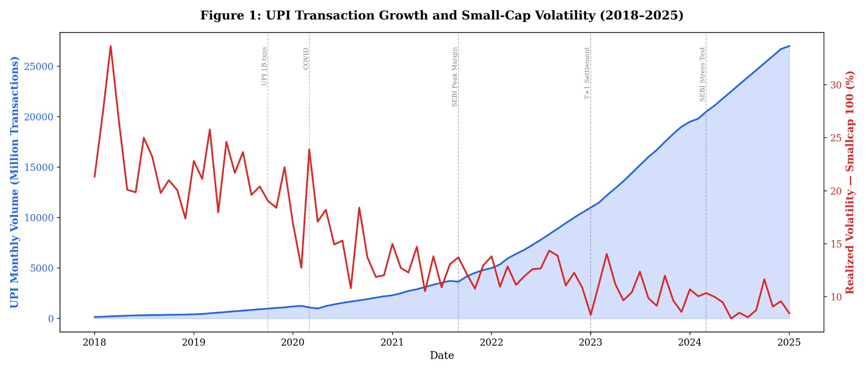
Figure 1. UPI transaction growth and Smallcap 100 realized volatility (2018–2025).

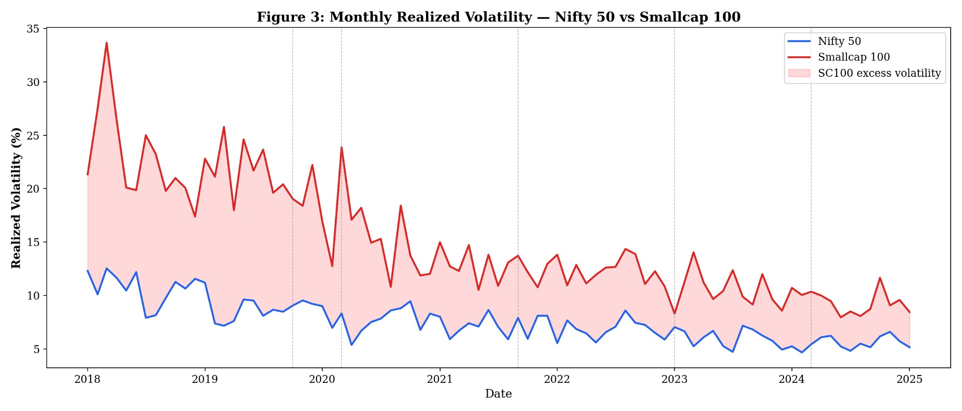
Figure 3. Monthly realized volatility: Nifty 50 vs Smallcap 100 (2018–2025).

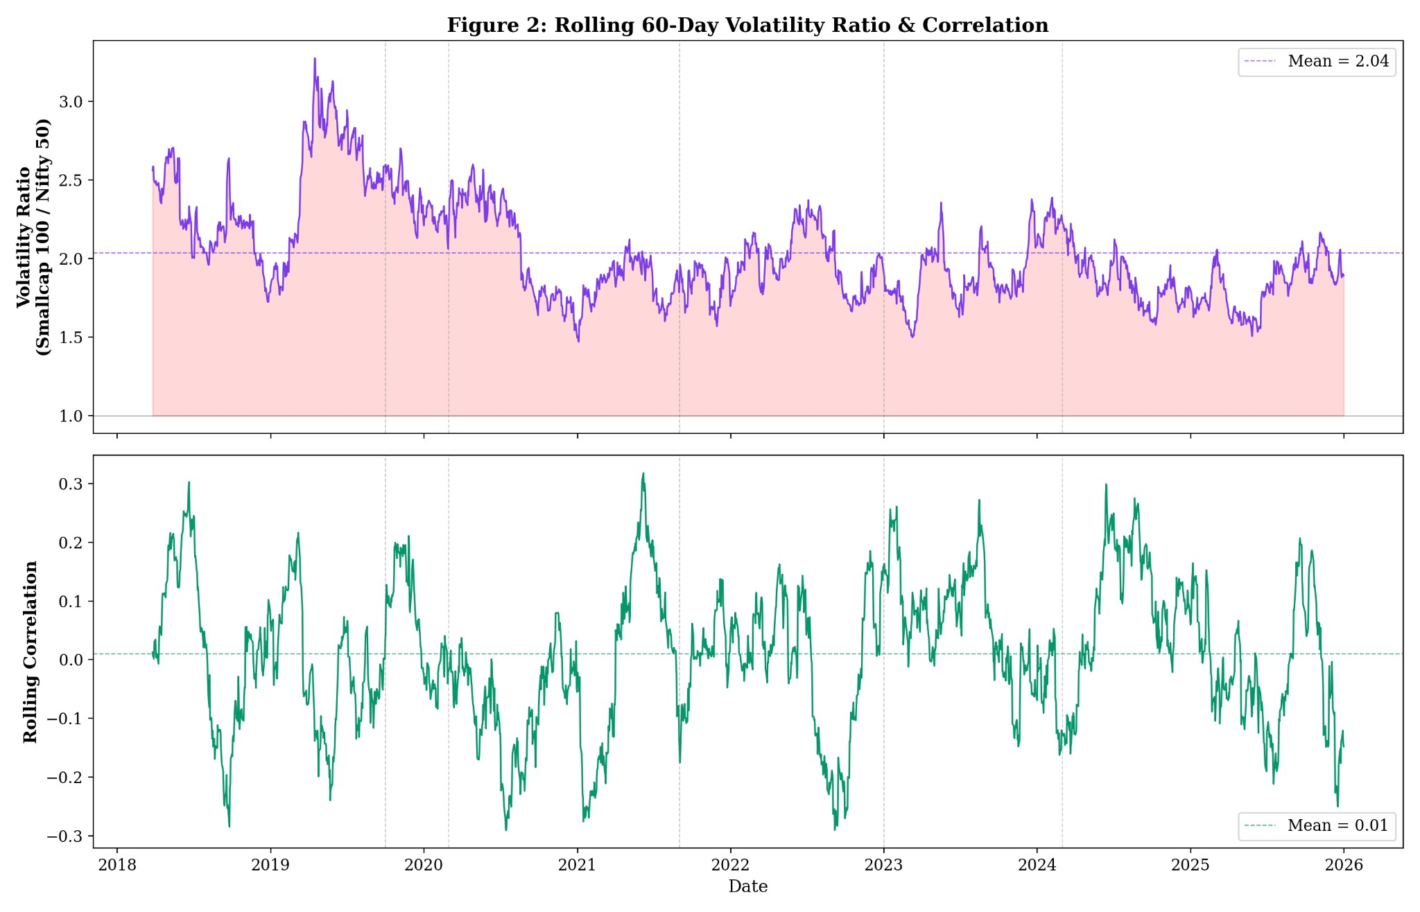
Figure 2. Rolling 60-day volatility ratio and rolling return correlation (exploratory).

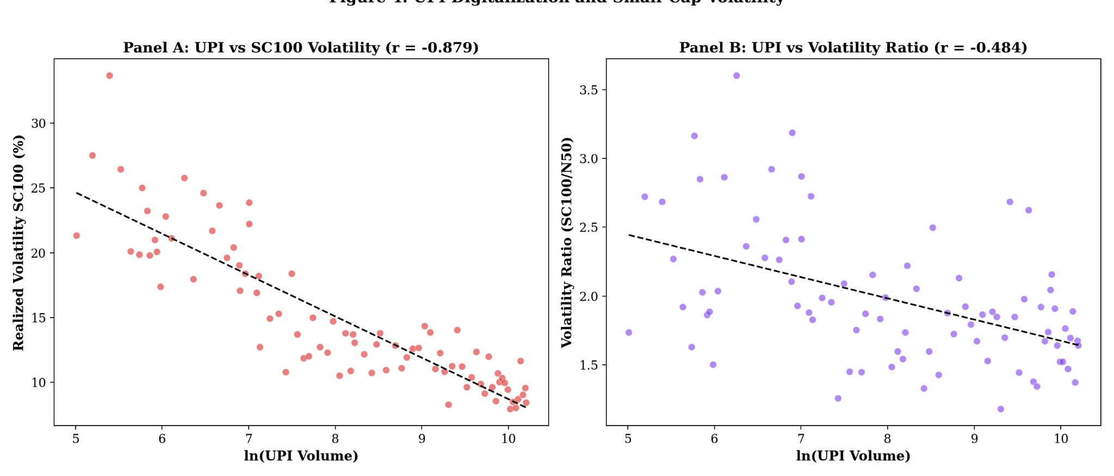

Figure 4. UPI digitalization and small-cap volatility: scatter evidence.

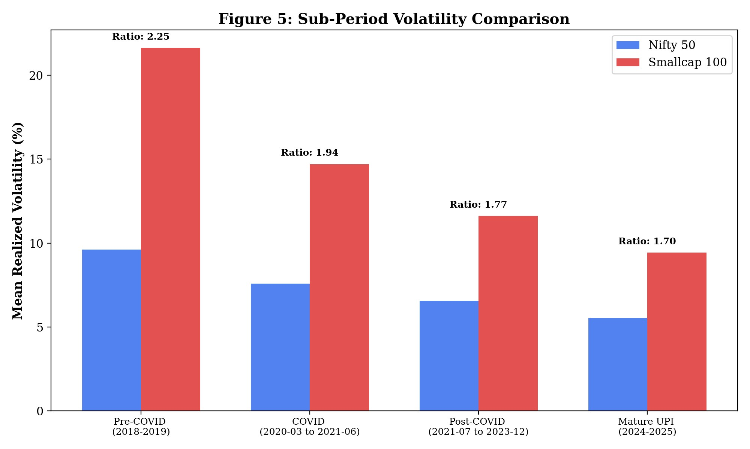
Figure 5. Sub-period volatility comparison (mean realized volatility).

DISCUSSION:
Summary of main findings. The empirical evidence supports H1 and H2: UPI scale is negatively associated with small-cap realized volatility and with the small-cap volatility wedge relative to large caps. The association is strong in levels and remains statistically significant under standard controls and HAC inference. H3 is supported by significant structural breaks around multiple adoption and policy milestones. H4 receives support from Granger tests showing that UPI predicts subsequent volatility changes, while reverse causality is inconsistent. H5 is supported by the attenuation pattern after January 2021.
Mechanism interpretation. The findings are consistent with a digitalization–liquidity channel: as UPI reduces frictions in funding and transferring money, it can broaden participation and stabilize household cash-management, enabling more continuous, diversified flows into financial assets. In thin small-cap markets, greater depth and risk-sharing can reduce realized volatility (Amihud, 2002; Chordia et al., 2001). At the same time, retail herding theories would predict destabilization if retail flows are synchronized and attention-driven (Bikhchandani et al., 1992; Chang et al., 2000). Our evidence suggests that, at the aggregate level, the stabilizing forces dominate over the sample, but the attenuation after 2021 indicates diminishing marginal stabilization as UPI reaches high penetration.
Alternative explanations. A key threat is spurious correlation from common trends: UPI rises mechanically over time while volatility fell from the elevated 2018–2020 regime. We partially address this by (a) controlling for market-wide volatility (Nifty 50 volatility), (b) including a time trend, (c) testing lagged effects, and (d) testing structural breaks and directionality. Nevertheless, the design remains observational; stronger causal claims would require additional controls (e.g., macro policy rates, global risk proxies, FII/DII flows) or quasi-experimental variation. Practical implications.
- Practical (FinTech/platform): Payment platforms can influence capital-market stability indirectly through funding rails, AutoPay, and integration with savings/investment products. Design choices that promote systematic investing (e.g., automated SIPs, frictionless but regulated account funding) can support more stable order flow.
- Managerial (brokers/asset managers): Brokers and asset managers should treat payment integration as a microstructure lever—reducing deposit friction can change retail flow timing and concentration. Risk controls and nudges (e.g., throttling leverage, encouraging staggered investment plans) may improve stability in small-cap segments.
- Policy (regulators): Regulators should monitor payment-led on-ramps to markets as potential channels for flow externalities. The presence of multiple structural breaks around margin and settlement reforms suggests that market-structure policies interact with digital rails; coordinated monitoring can help detect overheating in retail-driven small caps.

CONCLUSION:
This paper evaluates whether India’s UPI-led payment digitalization is associated with a structural change in small-cap equity volatility. Using monthly realized volatility for Nifty Smallcap 100 and Nifty 50 indices and monthly UPI transaction metrics (2018–2025), we document a strong negative association between UPI scale and small-cap volatility, a narrowing—but persistent—small-cap volatility wedge, and multiple structural breaks aligned with adoption milestones and market reforms. Granger evidence and lagged regressions support temporal precedence from UPI growth to volatility changes, though causal claims remain limited by observational design. Overall, the findings suggest that national digital payment infrastructure can have second-order effects on capital market stability, motivating further research and coordinated policy monitoring.

LIMITATIONS AND FUTURE RESEARCH:
Identification. The analysis is observational and cannot fully establish causality. UPI scale is highly trending and may proxy for broader macro-financial modernization. Although we include controls and structural/directionality checks, omitted variables remain a concern.
Measurement. We use realized volatility from daily index returns and aggregate UPI measures. Future work could use microstructure-level measures (bid–ask spreads, depth, order imbalance), fund flow data, or brokerage onboarding metrics to better test the liquidity channel.
Heterogeneity. The effect of UPI may differ across small-cap sectors, liquidity buckets, or investor composition. Disaggregated analysis could identify where stabilization is strongest or where retail flow externalities amplify risk.
Future research design. Quasi-experimental variation could come from phased feature rollouts (e.g., AutoPay), region-level adoption heterogeneity, or platform-level integration timing. Linking UPI adoption to brokerage account openings, SIP flows, and transaction-level equity data could clarify mechanisms.

REFERENCES:
- Amihud, Y. (2002). Illiquidity and stock returns: Cross-section and time-series effects. Journal of Financial Markets, 5(1), 31–56.
- Andersen, T. G., & Bollerslev, T. (1998). Answering the skeptics: Yes, standard volatility models do provide accurate forecasts. International Economic Review, 39(4), 885–905.
- Andersen, T. G., Bollerslev, T., Diebold, F. X., & Labys, P. (2001). The distribution of realized exchange rate volatility. Journal of the American Statistical Association, 96(453), 42–55.
- Banerjee, A. V. (1992). A simple model of herd behavior. Quarterly Journal of Economics, 107(3), 797–817.
- Barber, B. M., & Odean, T. (2008). All that glitters: The effect of attention and news on the buying behavior of individual and institutional investors. Review of Financial Studies, 21(2), 785–818.
- Barberis, N., Shleifer, A., & Vishny, R. (1998). A model of investor sentiment. Journal of Financial Economics, 49(3), 307–343.
- Barndorff-Nielsen, O. E., & Shephard, N. (2002). Econometric analysis of realized volatility and its use in estimating stochastic volatility models. Journal of the Royal Statistical Society: Series B, 64(2), 253–280.
- Bekaert, G., & Harvey, C. R. (1997). Emerging equity market volatility. Journal of Financial Economics, 43(1), 29–77.
- Bikhchandani, S., Hirshleifer, D., & Welch, I. (1992). A theory of fads, fashion, custom, and cultural change as informational cascades. Journal of Political Economy, 100(5), 992–1026.
- Bollen, N. P. B., & Whaley, R. E. (2004). Does net buying pressure affect the shape of implied volatility functions? Journal of Finance, 59(2), 711–753.
- Campbell, J. Y., Lo, A. W., & MacKinlay, A. C. (1997). The econometrics of financial markets. Princeton University Press.
- Carhart, M. M. (1997). On persistence in mutual fund performance. Journal of Finance, 52(1), 57–82.
- Chang, E. C., Cheng, J. W., & Khorana, A. (2000). An examination of herd behavior in equity markets. Journal of Banking & Finance, 24(10), 1651–1679.
- Chordia, T., Roll, R., & Subrahmanyam, A. (2001). Market liquidity and trading activity. Journal of Finance, 56(2), 501–530.
- Chow, G. C. (1960). Tests of equality between sets of coefficients in two linear regressions. Econometrica, 28(3), 591–605.
- Cristianini, N., & Shawe-Taylor, J. (2000). An introduction to support vector machines and other kernel-based learning methods. Cambridge University Press.
- Dickey, D. A., & Fuller, W. A. (1979). Distribution of the estimators for autoregressive time series with a unit root. Journal of the American Statistical Association, 74(366), 427–431.
- Engle, R. F. (1982). Autoregressive conditional heteroscedasticity with estimates of the variance of United Kingdom inflation. Econometrica, 50(4), 987–1007.
- Fama, E. F. (1970). Efficient capital markets: A review of theory and empirical work. Journal of Finance, 25(2), 383–417.
- Fama, E. F., & French, K. R. (1993). Common risk factors in the returns on stocks and bonds. Journal of Financial Economics, 33(1), 3–56.
- Forbes, K. J., & Rigobon, R. (2002). No contagion, only interdependence: Measuring stock market comovements. Journal of Finance, 57(5), 2223–2261.
- Granger, C. W. J. (1969). Investigating causal relations by econometric models and crossspectral methods. Econometrica, 37(3), 424–438.
- Hasbrouck, J. (2007). Empirical market microstructure: The institutions, economics, and econometrics of securities trading. Oxford University Press.
- Jack, W., & Suri, T. (2014). Risk sharing and transactions costs: Evidence from Kenya’s mobile money revolution. American Economic Review, 104(1), 183–223.
- Kyle, A. S. (1985). Continuous auctions and insider trading. Econometrica, 53(6), 1315–1335.
- Madhavan, A. (2000). Market microstructure: A survey. Journal of Financial Markets, 3(3), 205–258.
- Newey, W. K., & West, K. D. (1987). A simple, positive semi-definite, heteroskedasticity and autocorrelation consistent covariance matrix. Econometrica, 55(3), 703–708. O’Hara, M. (1995). Market microstructure theory. Blackwell.
- RBI. (various years). Payment system indicators and annual reports. Reserve Bank of India.
- NPCI. (various years). UPI product statistics and reports. National Payments Corporation of India.
- Suri, T., & Jack, W. (2016). The long-run poverty and gender impacts of mobile money. Science, 354(6317), 1288–1292.
- World Bank. (2022). Global Findex database 2021: Financial inclusion, digital payments, and resilience in the age of COVID-19. World Bank.

APPENDIX:
A1. Variable definitions.
- Smallcap 100 realized volatility (%): Monthly realized volatility computed from daily log returns, annualized (× 252) and expressed in percent.
- Nifty 50 realized volatility (%): Analogous realized volatility for Nifty 50.
- UPI volume (million): Monthly number of UPI transactions in millions.
- UPI value ( crores): Monthly UPI transaction value in crores.
- ln(UPI): Natural log of UPI volume (main) or value (robustness).
- COVID dummy: 1 for March 2020–June 2021, 0 otherwise.
- Volatility ratio: Smallcap 100 realized volatility divided by Nifty 50 realized volatility. A2. Notes on effect sizes.
A2. Notes on effect sizes.
Given a coefficient on ln(UPI), the effect of a _{p}% change in UPI is approximately Öln(1+_{p/}100).
For example, with = 3.19, a 10% increase implies Vol 3.19 × ln(1.10) 0.30 percentage points.

A3 Replication.
All computations can be replicated from the provided datasets and analysis scripts by:
(a) constructing monthly realized volatility from daily prices
(b) merging with monthly UPI series by month
(c) estimating OLS with Newey–West HAC standard errors (3 lags), and
(d) running Chow and Granger tests as specified.

CERTIFICATE



